Languages/frameworks used for implementation:

Node.js   
Express.js

MongoDB

JavaScript

JSON

HTML

CSS

Bootstrap

Screenshots for main functionalities:

(Note: the browser window size has been reduced to fit the entire page in the screenshots.)

When user clicks on menu button pizza pasta burger drinks displayed pagination

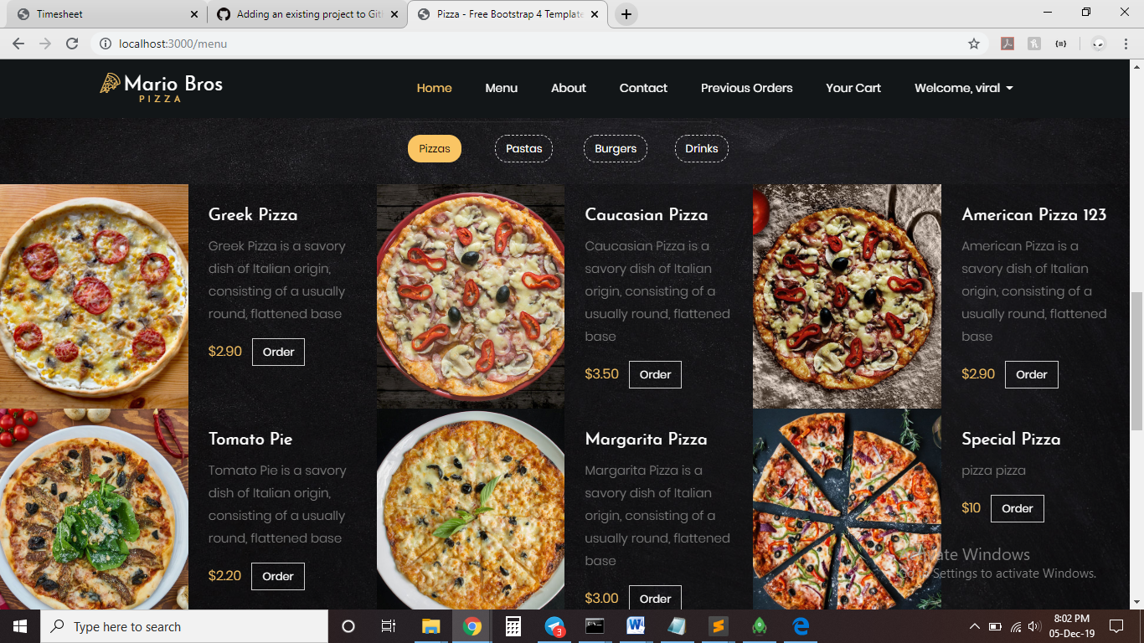

User can filter results based on any category he/she wants. Here in the screenshot we are filtering the results based on the ingredients as cheese in the pasta category. Therefore it displays all options of pasta that has cheese in it.

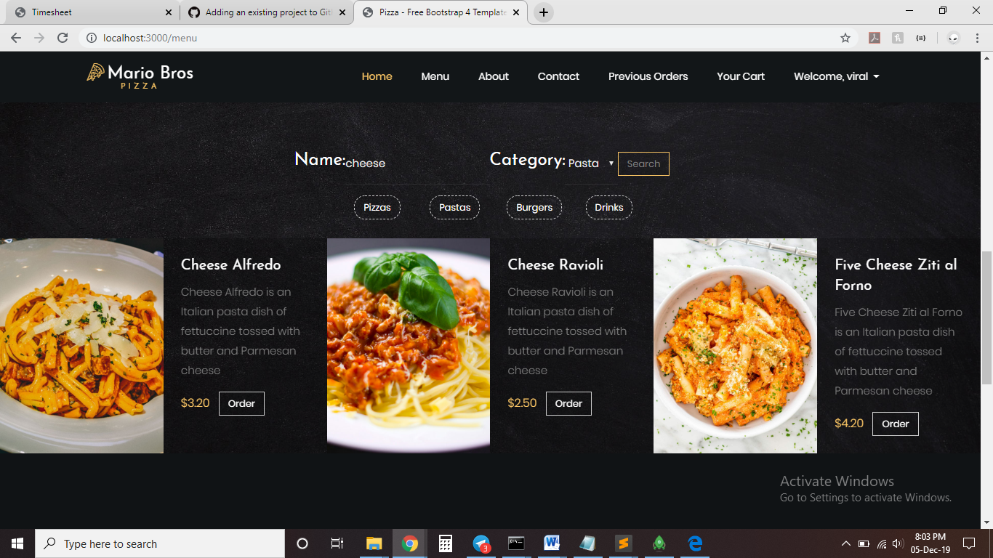

When the user adds a dish to the cart, the cart page is rendered that shows all current items in the user’s cart. The user can update the cart by editing his/her order example to change the topping for a pizza or to increase the quantity of pasta. User can also remove a particular dish from the cart pressing the remove button. User can also see the total price of all the dishes. When the user clicks on the checkout button the order is placed and is added to user’s previous order.

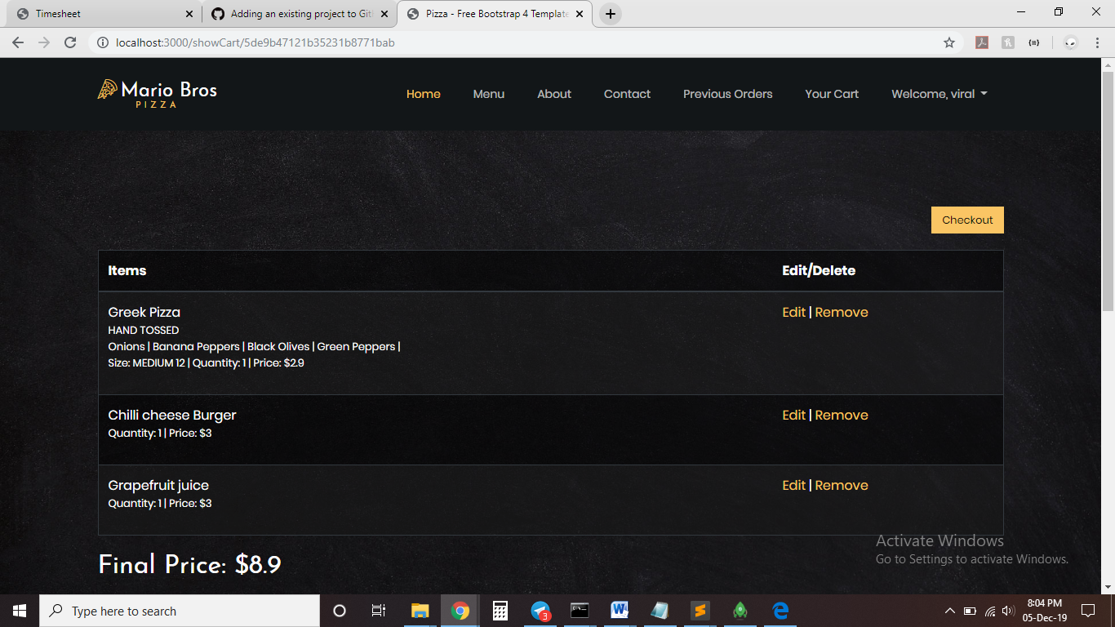

User can check his/her previous order by clicking on previous orders. User’s previous orders are displayed along with unique order number for each order that the user ordered along with the total price of that order and the date and time for that order.

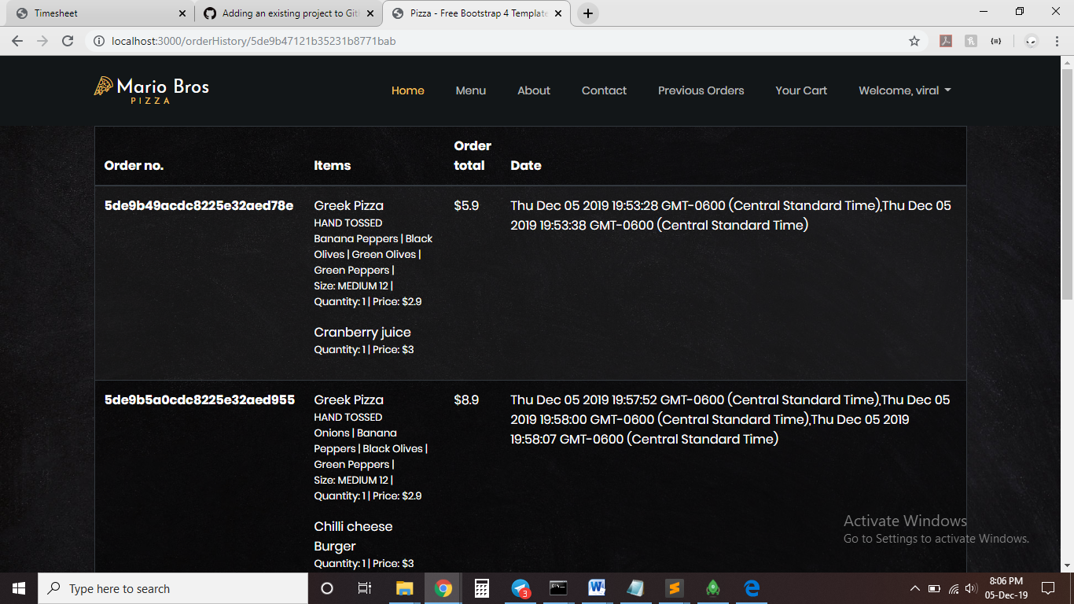

Admin functionalities

If the admin logs in and clicks on menu, the available options for the admin is to add, delete and edit dishes in the menu

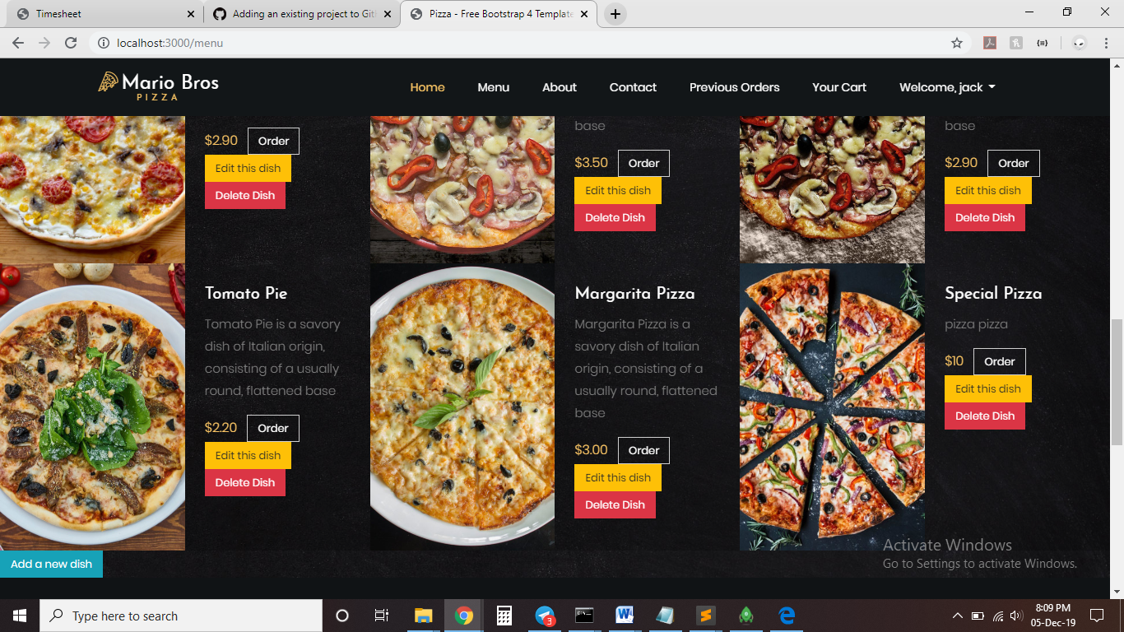

When the admin clicks on edit button

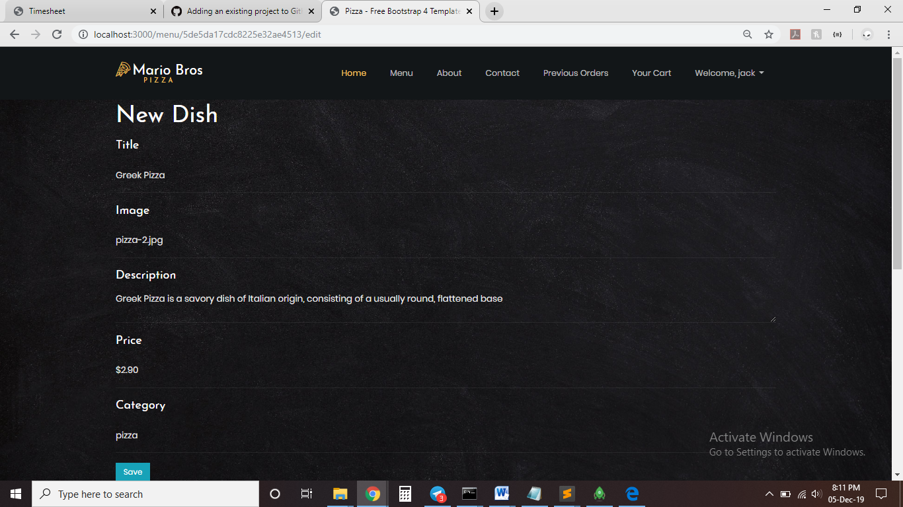

Admin can add new dishes to the menu by clicking on the button add new dish

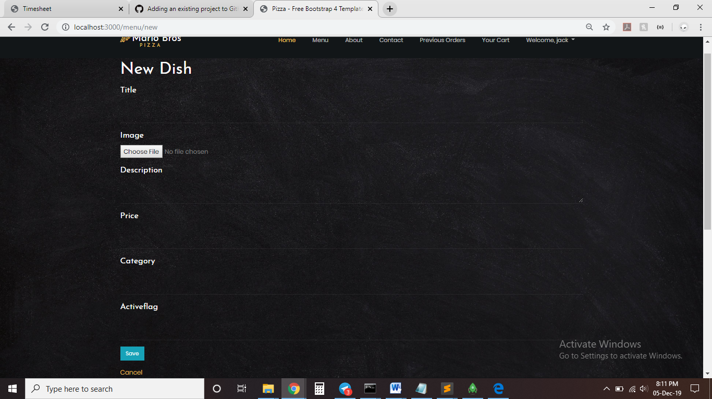

Team Members:

Dawson Sheldon Valerian(DVN170002)

Jenila Rakesh Sanghvi (JXS180012)

Viral Pradip Doshi (VPD180000)

Work division among team members:

Music collection creation and data – Akanksha, Meet

Accounts collection creation and data – Nikhil

Account and data creation: Viral, Jenila, Dawson

index.js - Dawson, Viral

user.js - Dawson,

menu.js - Dawson, Jenila

show.ejs- Dawson

about.ejs - Jenila

blog.ejs -Dawson

contact.ejs - Jenila. Viral

edit.ejs - Viral, Dawson

index.ejs- Dawson, Jenila

menu.ejs - Viral, Dawson

new.ejs - Dawson, Viral

header.ejs, footer.ejs - Dawson

service.ejs - Dawson, Jenila

show.ejs - Jenila, Viral

login.ejs - Dawson

register.ejs - Jenila, Viral

orderHistory.ejs - Dawson, Viral

menuPaging.ejs - Dawson, Jenila

login.ejs - Jenila, Viral

logout.jade - Dawson, Jenila

index.jade - Jenila, Dawson

error.jade - Dawson, Viral

error.ejs - Jenila, Viral

cart.ejs - Dawson, Jenila

cartedit.ejs - Jenila